CREATE A VPC

STEPS:

1) Go to services>networking >vpc

2) Click on select a vpc configuration

a)Click on vpc with a single subnet

3)Create vpc with a single subnet as below

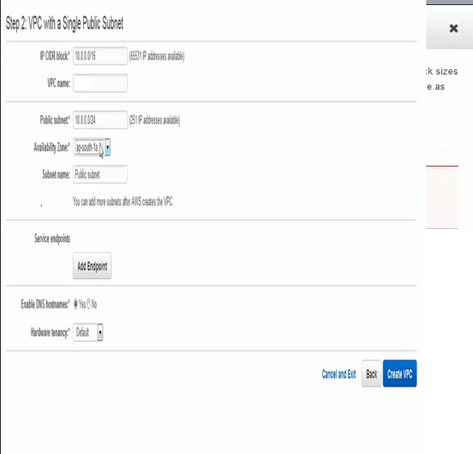

(public subnet ip should be similar to the local ipv4)

4)Click on create vpc

5)click on subnet>create subnet> create new subnet on ap-south1b>select the same precreated vpc as below

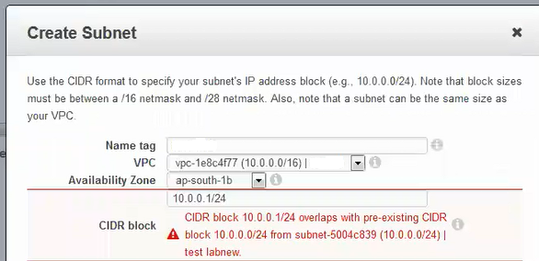

6)The created vpc and subnets are listed as below

